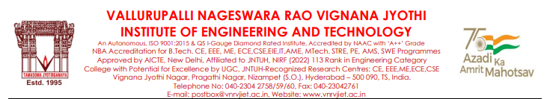

**Project Review Management System**

**Abstract**

**The Web-Based Project Review Management System, developed using the MERN stack, addresses inefficiencies in managing project reviews in educational institutions by streamlining processes and enhancing collaboration. Designed for four roles—Students, Guides, In-Charge, and Admin—the system offers tailored functionalities: In-Charge users organize projects by academic categories, monitor guide-student interactions, and archive completed projects; Guides review and approve proposals, update structured progress reports, and collaborate with students; Students access project updates, submit corrections, and track milestones; and Admins manage users and ensure platform functionality. Key features include real-time Progress Analytics with dashboards, Role-Based Notifications to ensure timely updates, AI-powered plagiarism detection, and Milestone Management for tracking critical deadlines. By simplifying reviews, fostering collaboration, and ensuring transparency, the system provides a robust, scalable solution for project management in Educational Institutions. Future enhancements will explore advanced analytics and expanded AI integration.**

**Domain: Academic Administration System**

**Team Members Guide**

**22071A3245 – Sai Kruthik Mrs. K . Swathi**

**22071A3254 – Sriram**

**22071A3255 – Bhargav**

**22071A3262 – Ratna Jashwanth**